Ideation Phase
Define the Problem Statements

Date | 28 NOVEMBER 2025
Team ID
Project Name | BOOK A DOCTOR
Maximum Marks | 2 Marks

Patient Problem Statement Template:
To define the core problems patient face while searching for doctor, and use those insights to guide the book a doctor consult.

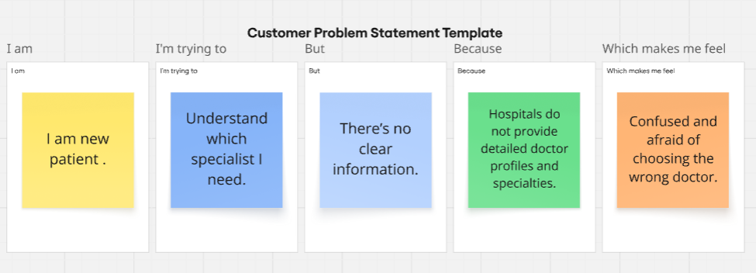
Reference: https://miro.com/templates/customer-problem-statement/

Problem Statement (PS) | I am (Customer) | I’m trying to | But | Because | Which makes me feel
PS-1 | Patient. | Book a doctor appointment quickly. | I can’t find available doctors in my time slot. | Hospital websites don't show real-time doctor availability. | irritated and anxious.
PS-2 | Working professional | Schedule a consultation without taking leave. | appointment timings clash with my work hours. | Most doctors only provide appointments during office hours. | Helpless and stressed.

